**User Limit, Session and expiry date**

**Overview:**

User login for the application is determine based on the license purchased. If the application have license for the 10 user means, that 10 user only access the application at the time. Also license parameter contains the session count for the user, based on that only number session will establish for the particular user.

**1 User limit**

User limit restriction setting will be takes place in context file. Example, if we set the user limit to 10 for application means, 10 users only have rights to access the application. In case 51 user try to login the application means below waring will through to user by system

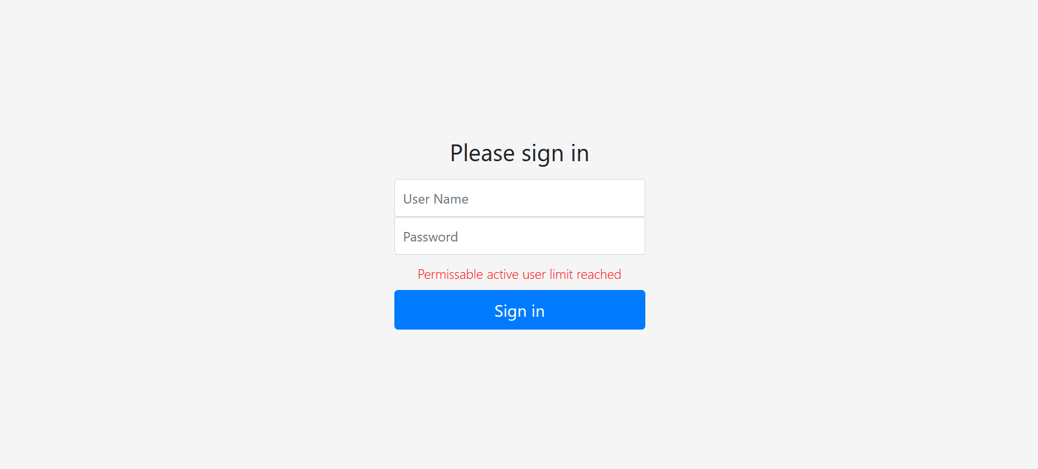

**2 User Session**

User session has been defined in the product key at context file. Based on that only session for user will establish.

**2.1 User with New Login Session**

While we login the user with new session means, application allow to login without any problem.

**2.1 User with Multiple Login Session**

When we try to login the user which already have one open login session means, system won’t allow to create new login session at different browser. It will stop the login process with message” Maximum sessions of 1 for this user exceeded”

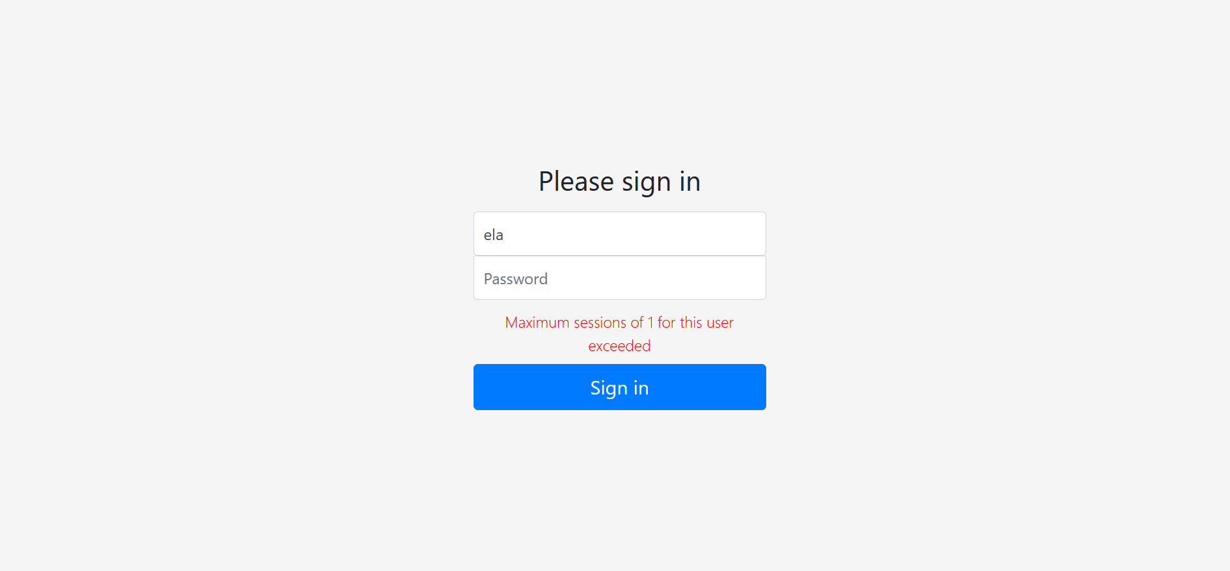

**3 License expiry**

License expiry date is determined in product key. When license gets expire means, application will not be in usable stage.